Use of Kepler for CAMM Workflow

If a Kepler workflow is used to call Dakota, it could serve as the user interface for the project. This workflow could also build the Dakota input file and modify the intelligent script from the input given. Here is an example workflow where the model parameters are specified in the runtime window:

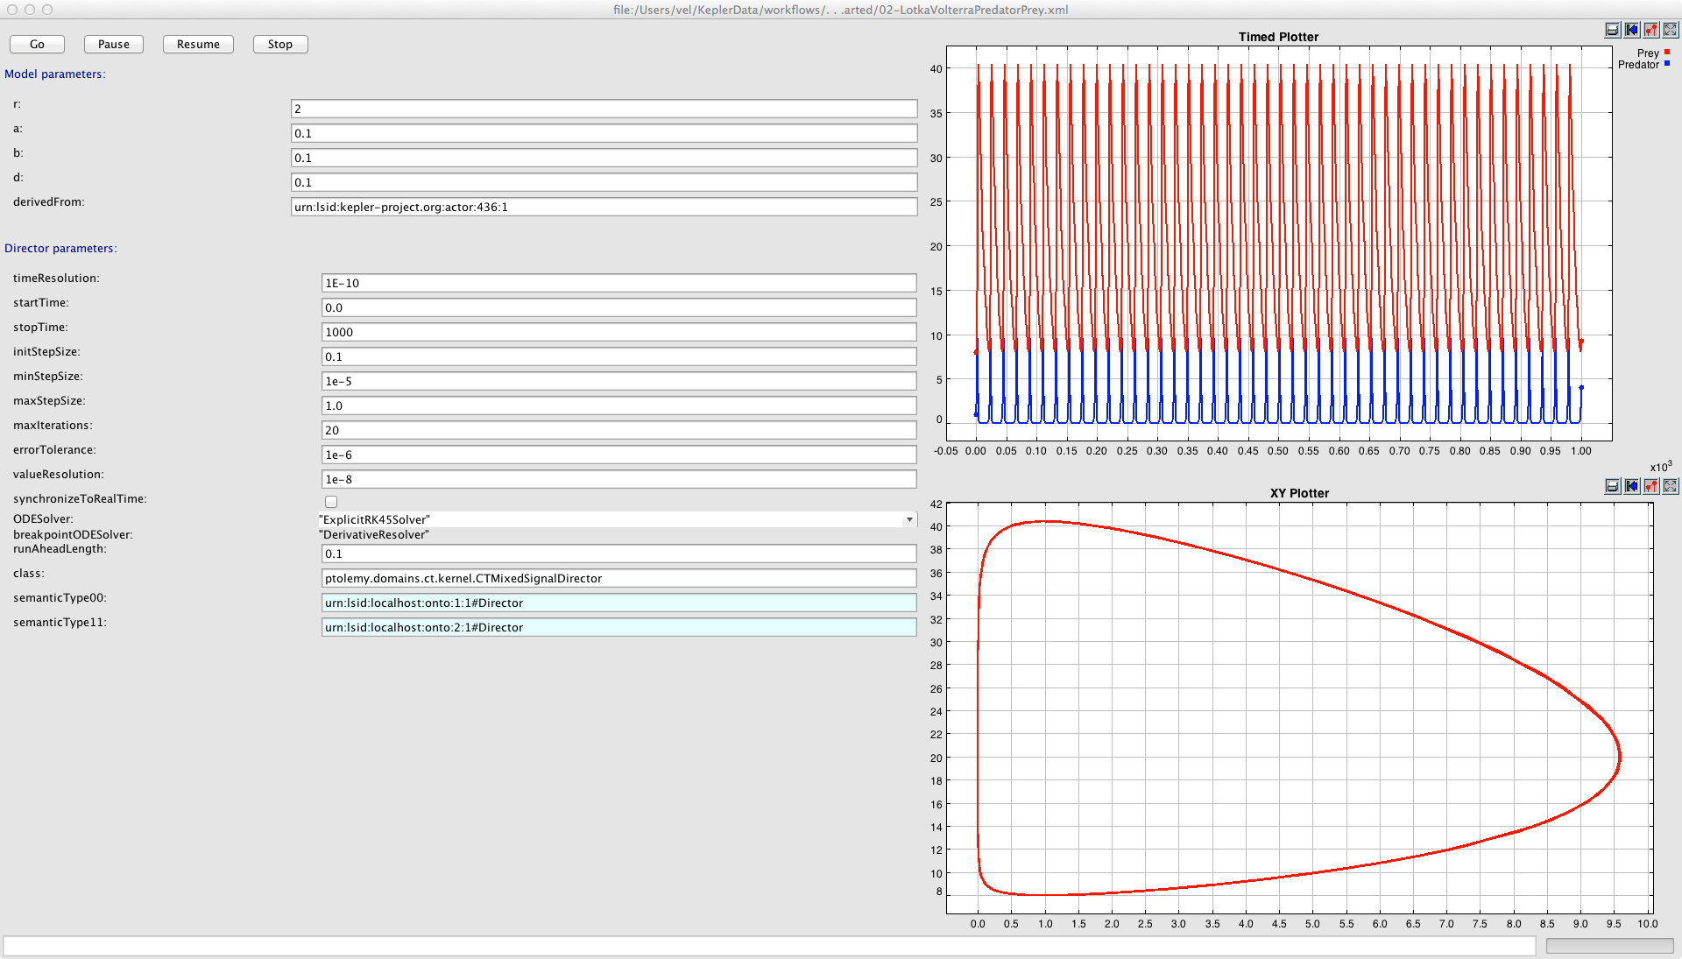

The intelligent workflow script could also be a Kepler workflow. Instead of Dakota calling a python script, this command could be issued with any needed parameters specified:

kepler -runwf workflow.xml -x 4 -y "foo"

The actors needed for the Dakota workflow would have to be written in Java. Boolean switches would be used with expressions for existence of file. Composite actors would manage the loading, submitting MD calculations, and convoluting with Resolution and adding background and scaling.